**Interface**: It is a blueprint of a class which defines the rules that a class has to implement.

Interface is an entity through which we can achieve 100% abstract.

To provide the implementation inside a class we have to write implements keyword.

We cannot create an object of interface. But we can create a reference variable of interface.

Example:

Interface1 i1 = **new** Browser1();

A class can implements multiple interface at the same time i.e multiple inheritance is possible in terms of interface.

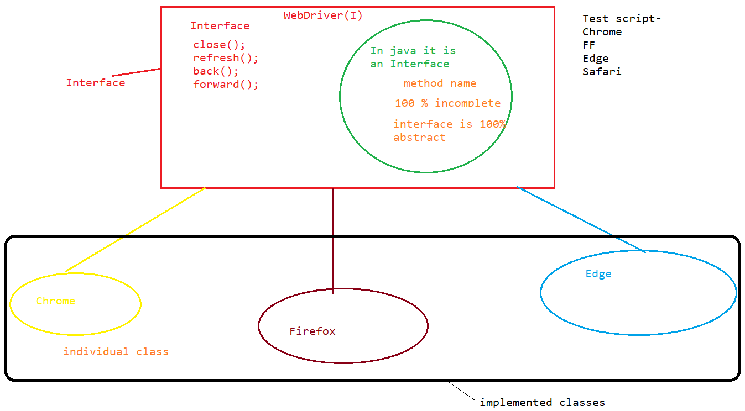

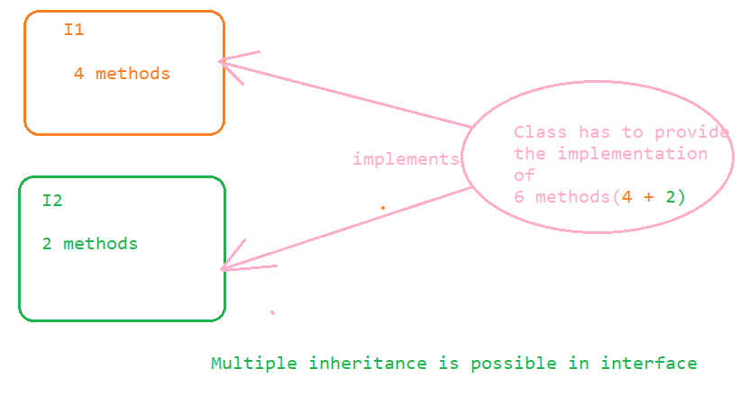

Through this diamond ambiguity problem gets resolve after using interface.

Example:

**public** **interface** Interface1 {

**void** close();

**public** **abstract** **void** back();

**public** **void** refresh();

**public** **interface** Interface2 {

**public** **void** m1();

**public** **void** m2();

**public** **void** m3();

**public** **void** m4();

}**public** **class** Test2 **implements** Interface2, Interface1 {

**public** **void** close() {

}

**public** **void** back() {

}

**public** **void** refresh() {

}

**public** **void** m1() {

}

**public** **void** m2() {

}

**public** **void** m3() {

}

**public** **void** m4() {

}

}

**Methods in an Interface:**

1. Every method(non-static) inside an interface is by default public and abstract whether we declare it or not.

Example:

**package** interfacediscussion;

**public** **interface** Interface1 {

**void** close();

**public** **abstract** **void** back();

**public** **void** refresh();

// all the above methods are having the same category i.e public and abstract.

}**public** **class** Browser1 **implements** Interface1 {

**public** **void** close() {

System.***out***.println("close method of browser 1");

}

**public** **void** back() {

System.***out***.println("back method of browser 1");

}

**public** **void** refresh() {

System.***out***.println("refresh method of browser 1");

}

}

2. Inside an interface we can only have complete static method inside it. All the static method inside an interface is by default public and concrete.

Example:

**public** **interface** Interface1 {

**static** **void** m1()

{

System.***out***.println("M1 static method");

}

**public** **static** **void** main(String[] args) {

*m1*();

Interface1.*m1*();

}

}

In the above example of static method it is by default public whether we declare it or not.

Variables inside an interface:

By default all the variables inside an interface are public static and final whether we define them or not.

Example:

**public** **interface** VariablesInInterface {

**public** **static** **final** String ***s*** = "abc";// static String s = "abc" // final String s = "abc"

// Above variables are the same one

**boolean** ***k*** = **false**;

**public** **static** **void** main(String[] args) {

System.***out***.println(***s***);

}

Note: In the above example s variable is public static and final whether we declare it or not.

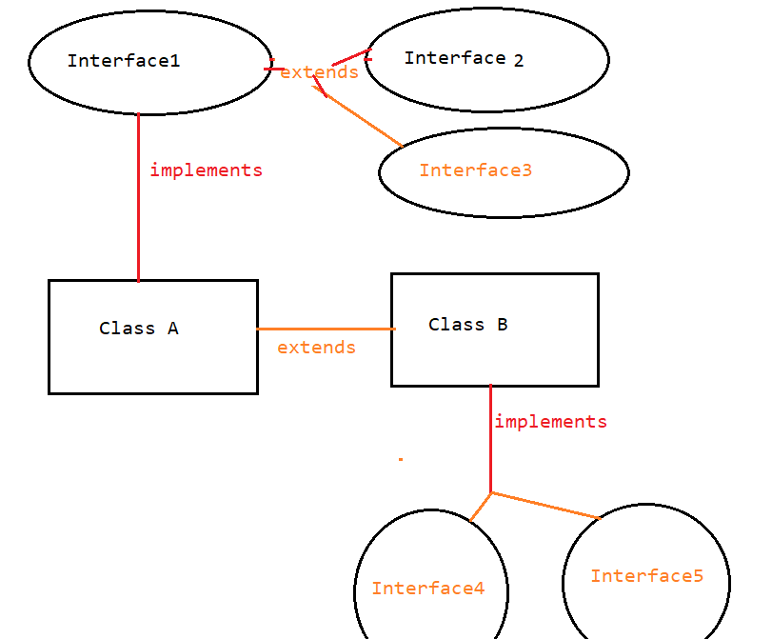

Note: Whenever the same categories we have to connect then we use extends keyword and if we need to connect the different one then we have to use implements keyword.

Example of same variable inside two interfaces:

**public** **interface** Interface1 {

**int** ***i*** = 50;

}

**public** **interface** Interface2 {

**int** ***i***=60;

}

**public** **interface** Interface3 **extends** Interface1, Interface2 {

**public** **static** **void** main(String[] args) {

System.***out***.println(Interface2.***i***);// interface2 i value

System.***out***.println(Interface1.***i***);// interface1 i value

}

}

Difference between Interface and Abstract:

|  |  |  |
| --- | --- | --- |
| **Sr. No.** | **Interface** | **Abstract class** |
| 1 | If don’t know anything about the implementation then we should go for interface. | If we know partial implementation then we should go for abstract class. |
| 2 | Inside an interface every method is by default public and abstract whether we declare it or not. | Every method present inside an abstract class need not be public and abstract we can have concrete method as well. |
| 3 | Inside the interface every method is public and abstract but we cannot use : private  protected  final | There are no restrictions on abstract class for those method which can be extended. |
| 4 | Every variable inside an interface is by default public, static and final whether we declare it or not. | Every variable present inside an abstract class need not be public static and final. |
| 5 | Constructor is not applicable. | Constructor is applicable. |